

School of Computing
Department of Computer Science and Engineering
USE CASE REAL LIFE EXAMPLE
Program- Department Name | B.Tech – CSE
Academic Year/Semester | 2026-2027 Summer
Faculty Name | Dr. Suchitra. S
Course Code/Course Name | 10211CS227 / Problem Solving and Testing
Slot No & Date | S9-2L2L12
Student Name (s) | A RAKESH
Title of the Complex Engineering problem / problems | SUPERMARKET BILLING SYSTEM
Description / Complexity Addressed | A Supermarket Billing System addresses the complexities of running day-to-day retail operations: managing products, generating accurate bills, applying discounts and coupons, and tracking inventory. The system calculates totals with 5% GST, applies bulk discounts and coupon rules with minimum-bill checks, deducts stock automatically on every sale, detects low-stock items, and analyses sales patterns such as most sold products, peak sales periods and customer purchase behaviour. It demonstrates object-oriented programming, data structures, business logic, file handling and input validation to develop a reliable billing application.
CO’s Mapped | CO1, CO2, CO3, CO4, CO5
PO’s / PSO’s Mapped | PO1, PO2, PO3, PO5, PSO2
SDG Mapped with number | 8
Justification for SDG Mapped | The Supermarket Billing System supports SDG 8 (Decent Work and Economic Growth) by using technology to improve the productivity and efficiency of retail businesses. Automated billing removes manual calculation errors, speeds up checkout, keeps stock levels accurate, and gives store owners sales insights that support better business decisions and sustainable economic growth.
Proof for the solved Complex Engineering Problem | Complete Python source code (Section 3), output screenshots of all modules (Section 4), and the invoice text files generated by the program (invoices/INV*.txt).

Signature of the Faculty

TABLE OF CONTENTS

S.No. | Contents | Page No.
1. | Use-case | 3
2. | Problem Statement | 4
3. | Code | 5
4. | Output Screenshot | 11
5. | Result | 15

Faculty Signature

CASE STUDY
Supermarket Billing System
The Supermarket Billing System is a console-based application developed in Python that automates the day-to-day operations of a retail store: product management, customer billing, discounts and inventory tracking.
The main objective is to replace manual billing with a fast and accurate system that generates invoices, updates stock automatically and gives the store owner useful sales insights.
It demonstrates key concepts such as:
  - Object-oriented programming (Product, Inventory, BillingSystem and Analytics classes)
  - Data structures (dictionaries, lists and sorting with key functions)
  - Business logic (bulk discounts, coupons and GST calculation)
  - File handling (each invoice is saved as a text file)
This project serves as an example of applying modular design and data analysis in Python.
The user works through a simple numbered menu to manage products, create bills, monitor stock and view analytics.

Problem Statement
Manual billing in retail stores leads to slow checkout, calculation errors, poor stock visibility and no insight into customer buying behaviour. This project develops a console-based Supermarket Billing System in Python that manages products, customer billing, discounts and inventory operations efficiently.
The system should:
  - Add and remove products
  - Generate bills
  - Apply discounts
  - Track inventory
  - Analyze sales patterns
Functional Requirements

Billing
  - Calculate the total bill (price x quantity plus 5% GST).
  - Apply coupons and discounts: 10% bulk discount on 5 or more units of an item, and coupons SAVE10, FLAT50 and WELCOME5 with minimum-bill checks.
  - Generate a formatted invoice with a unique invoice number and save it to a file.

Inventory Management
  - Update stock by adding or reducing quantities; stock is deducted automatically on every sale.
  - Detect low-stock products (10 units or fewer).
  - Sort products by number of units sold.

Analytics
  - Most sold products.
  - Peak sales periods (morning, afternoon, evening and the busiest hour).
  - Customer purchase analysis: visits, total spent, average bill and favourite item.

Technical Highlights
  - Standard library only: datetime, collections and os; no external packages.
  - Modular OOP design: Product, Inventory, Sale, BillingSystem and Analytics classes.
  - Input validation: unknown product IDs, quantities beyond stock, invalid coupons and non-numeric input are handled.
  - Sample data: products and past sales are preloaded so that analytics can be demonstrated immediately.

Code
import os
from datetime import datetime, timedelta
from collections import defaultdict

GST_RATE = 0.05
LOW_STOCK_LIMIT = 10
BULK_QTY, BULK_DISCOUNT = 5, 0.10 # 10% off a line when qty >= 5
COUPONS = { # code: (type, value, min_bill)
"SAVE10": ("percent", 10, 200),
"FLAT50": ("flat", 50, 500),
"WELCOME5": ("percent", 5, 0),
}

class Product:
def __init__(self, pid, name, price, stock):
self.pid, self.name = pid, name
self.price, self.stock = price, stock
self.sold = 0

class Inventory:
def __init__(self):
self.products = {}

def add(self, pid, name, price, stock):
if pid in self.products:
return False
self.products[pid] = Product(pid, name, price, stock)
return True

def remove(self, pid):
return self.products.pop(pid, None) is not None

def update_stock(self, pid, qty):
if pid not in self.products:
return False
self.products[pid].stock += qty
return self.products[pid].stock >= 0

def low_stock(self):
return [p for p in self.products.values() if p.stock <= LOW_STOCK_LIMIT]

def sorted_by_sales(self):
return sorted(self.products.values(), key=lambda p: p.sold, reverse=True)

def show(self, items=None):
items = items if items is not None else self.products.values()
print(f"{'ID':<6}{'Name':<20}{'Price':>9}{'Stock':>8}{'Sold':>7}")
print("-" * 50)
for p in items:
print(f"{p.pid:<6}{p.name:<20}{p.price:>9.2f}{p.stock:>8}{p.sold:>7}")

class Sale:
def __init__(self, invoice_no, customer, lines, total, when):
self.invoice_no, self.customer = invoice_no, customer
self.lines, self.total, self.when = lines, total, when

class BillingSystem:
def __init__(self, inventory):
self.inv = inventory
self.sales = []
self.counter = 1000

def calculate(self, cart, coupon=None):
lines, subtotal, item_disc = [], 0.0, 0.0
for pid, qty in cart.items():
p = self.inv.products[pid]
amount = p.price * qty
disc = amount * BULK_DISCOUNT if qty >= BULK_QTY else 0.0
lines.append((p.name, qty, p.price, amount, disc))
subtotal += amount
item_disc += disc
after_items = subtotal - item_disc
coupon_disc, msg = 0.0, ""
if coupon:
rule = COUPONS.get(coupon.upper())
if not rule:
msg = "Invalid coupon"
elif after_items < rule[2]:
msg = f"Coupon needs a minimum bill of Rs.{rule[2]}"
else:
coupon_disc = after_items * rule[1] / 100 if rule[0] == "percent" else rule[1]
msg = f"Coupon {coupon.upper()} applied"
taxable = after_items - coupon_disc
gst = taxable * GST_RATE
return dict(lines=lines, subtotal=subtotal, item_disc=item_disc,
coupon_disc=coupon_disc, gst=gst, total=taxable + gst, msg=msg)

def checkout(self, customer, cart, coupon=None, when=None):
bill = self.calculate(cart, coupon)
for pid, qty in cart.items():
self.inv.products[pid].stock -= qty
self.inv.products[pid].sold += qty
self.counter += 1
inv_no = f"INV{self.counter}"
when = when or datetime.now()
names = {self.inv.products[pid].name: q for pid, q in cart.items()}
self.sales.append(Sale(inv_no, customer, names, bill["total"], when))
return inv_no, bill, when

@staticmethod
def invoice_text(inv_no, customer, bill, when):
out = ["=" * 52, " FRESHMART SUPERMARKET - INVOICE", "=" * 52,
f"Invoice : {inv_no}", f"Date : {when:%d-%m-%Y %H:%M}",
f"Customer: {customer}", "-" * 52,
f"{'Item':<18}{'Qty':>5}{'Price':>9}{'Amount':>10}{'Disc':>8}", "-" * 52]
for n, q, pr, amt, d in bill["lines"]:
out.append(f"{n:<18}{q:>5}{pr:>9.2f}{amt:>10.2f}{d:>8.2f}")
out += ["-" * 52,
f"{'Subtotal':<38}{bill['subtotal']:>14.2f}",
f"{'Bulk discount':<38}{-bill['item_disc']:>14.2f}",
f"{'Coupon discount':<38}{-bill['coupon_disc']:>14.2f}",
f"{'GST (5%)':<38}{bill['gst']:>14.2f}",
"=" * 52, f"{'GRAND TOTAL (Rs.)':<38}{bill['total']:>14.2f}", "=" * 52,
" Thank you! Visit again."]
return "\n".join(out)

class Analytics:
def __init__(self, system):
self.s = system

def most_sold(self, n=5):
print("\nMOST SOLD PRODUCTS")
for i, p in enumerate(self.s.inv.sorted_by_sales()[:n], 1):
print(f"{i}. {p.name:<20} {p.sold} units")

def peak_periods(self):
slots = {"Morning (6-12)": 0, "Afternoon (12-17)": 0, "Evening (17-22)": 0}
hours = defaultdict(float)
for sale in self.s.sales:
h = sale.when.hour
hours[h] += sale.total
key = ("Morning (6-12)" if 6 <= h < 12 else
"Afternoon (12-17)" if 12 <= h < 17 else "Evening (17-22)")
slots[key] += 1
print("\nPEAK SALES PERIODS")
for k, v in slots.items():
print(f"{k:<20} {v:>3} bills {'#' * v}")
busiest = max(hours, key=hours.get)
print(f"Busiest hour: {busiest}:00-{busiest + 1}:00 (Rs.{hours[busiest]:.2f})")

def customers(self):
data = defaultdict(lambda: [0, 0.0, defaultdict(int)])
for sale in self.s.sales:
d = data[sale.customer]
d[0] += 1
d[1] += sale.total
for n, q in sale.lines.items():
d[2][n] += q
print("\nCUSTOMER PURCHASE ANALYSIS")
print(f"{'Customer':<12}{'Visits':>7}{'Spent':>11}{'Avg Bill':>11} Favourite")
for c, (v, t, items) in sorted(data.items(), key=lambda x: -x[1][1]):
fav = max(items, key=items.get)
print(f"{c:<12}{v:>7}{t:>11.2f}{t / v:>11.2f} {fav}")
top = max(data, key=lambda c: data[c][1])
print(f"Top customer: {top}")

def seed(system):
inv = system.inv
for row in [("P01", "Basmati Rice 1kg", 95, 60), ("P02", "Toor Dal 1kg", 140, 40),
("P03", "Sunflower Oil 1L", 150, 30), ("P04", "Milk 500ml", 28, 80),
("P05", "Bread", 40, 8), ("P06", "Tea Powder 250g", 120, 25),
("P07", "Biscuits", 20, 100), ("P08", "Soap", 35, 9)]:
inv.add(*row)
base = datetime.now().replace(minute=0, second=0, microsecond=0)
history = [
("Arun", {"P04": 6, "P05": 2}, 8, "SAVE10"),
("Priya", {"P01": 2, "P02": 1}, 10, None),
("Arun", {"P07": 10, "P04": 3}, 9, None),
("Meena", {"P03": 1, "P06": 2}, 18, "FLAT50"),
("Priya", {"P04": 5, "P07": 5}, 19, None),
("Karthik", {"P01": 1, "P08": 1}, 13, None),
("Meena", {"P04": 4, "P05": 3}, 18, None),
("Arun", {"P07": 6, "P02": 1}, 19, "WELCOME5"),
]
for cust, cart, hour, code in history:
system.checkout(cust, cart, code, base.replace(hour=hour) - timedelta(days=1))

def read_int(prompt):
try:
return int(input(prompt))
except ValueError:
print("Enter a valid number.")
return None

def new_bill(system):
customer = input("Customer name: ").strip() or "Guest"
cart = {}
while True:
pid = input("Product ID (blank to finish): ").strip().upper()
if not pid:
break
p = system.inv.products.get(pid)
if not p:
print("Product not found.")
continue
qty = read_int(f" Qty for {p.name}: ")
if not qty or qty <= 0:
continue
if qty + cart.get(pid, 0) > p.stock:
print(f" Only {p.stock} in stock.")
continue
cart[pid] = cart.get(pid, 0) + qty
if not cart:
print("Cart is empty.")
return
coupon = input("Coupon code (blank for none): ").strip() or None
preview = system.calculate(cart, coupon)
if preview["msg"]:
print(">>", preview["msg"])
inv_no, bill, when = system.checkout(customer, cart, coupon)
text = system.invoice_text(inv_no, customer, bill, when)
print("\n" + text)
os.makedirs("invoices", exist_ok=True)
with open(f"invoices/{inv_no}.txt", "w") as f:
f.write(text)
print(f"\nInvoice saved to invoices/{inv_no}.txt")

def main():
system = BillingSystem(Inventory())
seed(system)
inv, stats = system.inv, Analytics(system)
menu = """
========== SUPERMARKET BILLING SYSTEM ==========
1. Add product 6. Low-stock alert
2. Remove product 7. Products sorted by sales
3. View inventory 8. Sales analytics
4. Update stock 9. New bill
0. Exit
================================================"""
while True:
print(menu)
ch = input("Choice: ").strip()
if ch == "1":
pid, name = input("ID: ").strip().upper(), input("Name: ").strip()
try:
price, stock = float(input("Price: ")), int(input("Stock: "))
except ValueError:
print("Invalid price/stock.")
continue
print("Product added." if inv.add(pid, name, price, stock) else "ID already exists.")
elif ch == "2":
print("Removed." if inv.remove(input("ID: ").strip().upper()) else "Not found.")
elif ch == "3":
inv.show()
elif ch == "4":
pid = input("ID: ").strip().upper()
qty = read_int("Qty to add (negative to reduce): ")
if qty is not None:
print("Stock updated." if inv.update_stock(pid, qty) else "Invalid ID or stock.")
elif ch == "6":
low = inv.low_stock()
print(f"\nLOW STOCK (<= {LOW_STOCK_LIMIT})" if low else "All stock levels fine.")
if low:
inv.show(low)
elif ch == "7":
inv.show(inv.sorted_by_sales())
elif ch == "8":
stats.most_sold()
stats.peak_periods()
stats.customers()
elif ch == "9":
new_bill(system)
elif ch == "0":
print("Goodbye!")
break
else:
print("Invalid choice.")

if __name__ == "__main__":
main()

OUTPUT SCREENSHOT
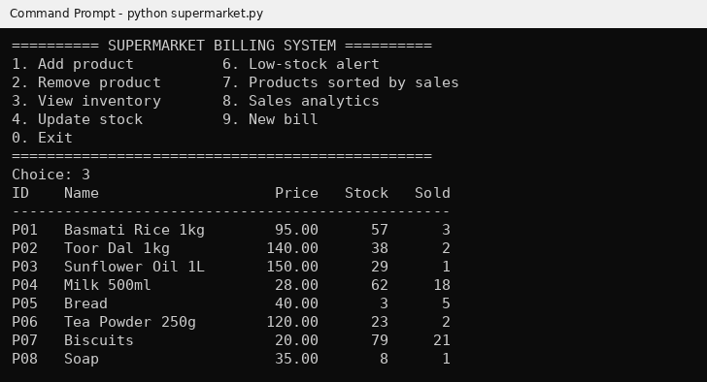
Figure 1: Main menu and View inventory
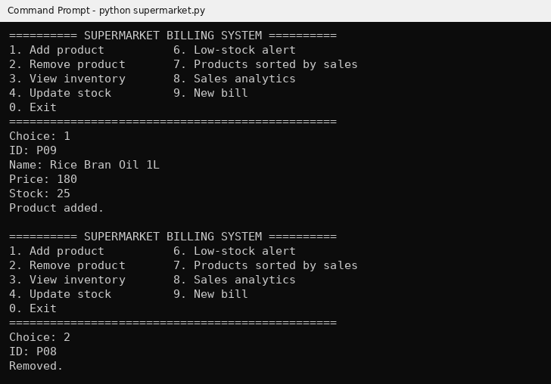
Figure 2: Add product (P09) and Remove product (P08)
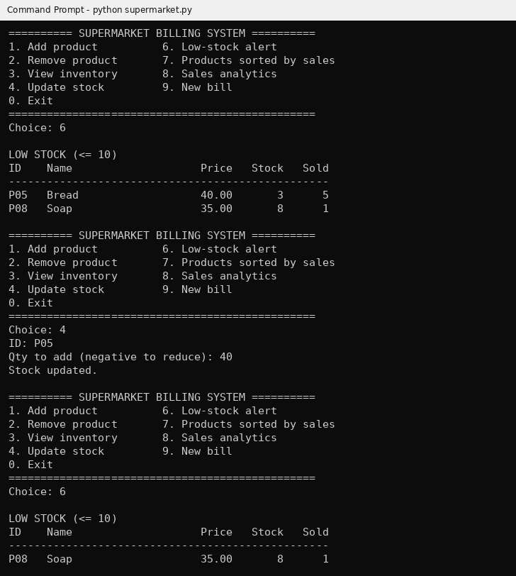
Figure 3: Low-stock alert before and after Update stock (Bread +40)
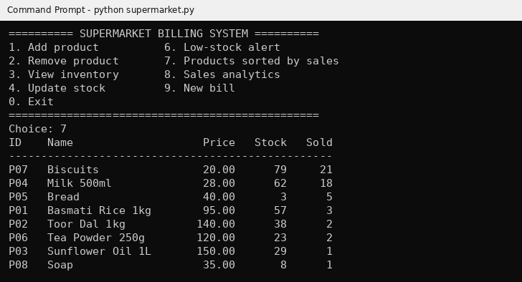
Figure 4: Products sorted by sales
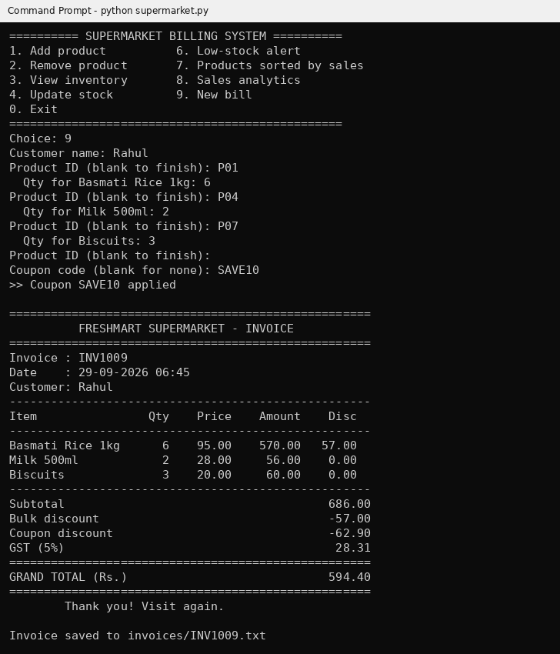
Figure 5: Generate bill with bulk discount, coupon SAVE10 and GST
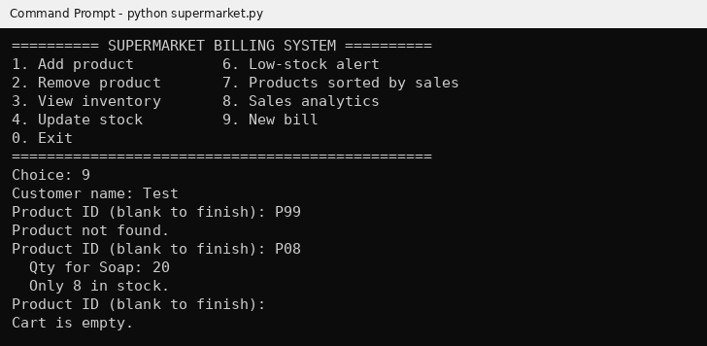
Figure 6: Input validation: unknown product and quantity above stock
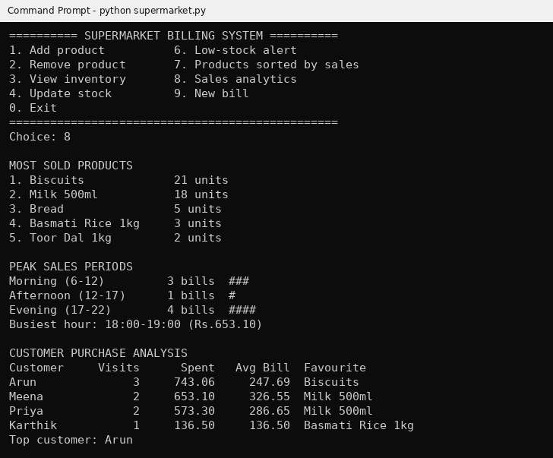
Figure 7: Sales analytics: most sold, peak periods and customer analysis

- Result
The Supermarket Billing System was designed, implemented and tested as a console application in Python, and the intended objective was achieved. The following requirements were met:
  - Products can be added, removed and viewed, and stock is updated automatically after every sale.
  - Bills are calculated with bulk discounts, coupons and 5% GST, and invoices are generated and saved to text files.
  - Low-stock products are detected and products can be sorted by units sold.
  - Analytics report the most sold products, peak sales periods and customer purchase patterns.
Input validation prevents billing errors such as unknown products, quantities above stock and invalid coupons.

